**Lab Tasks**

**By**

**FARWA RASHID (45945)**

**Subject**: Operating System

**( LAB 10 )**

**Date**: 29/10/2024

**BSCS SEMESTER – 5**

**RIPHAH INTERNATIONAL UNIVERSITY**

**ISLAMABAD**

**Task 01: How do you create a basic for loop in a shell script to iterate over a list of numbers from 1 to 5?**

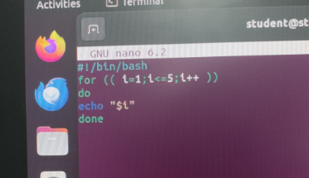

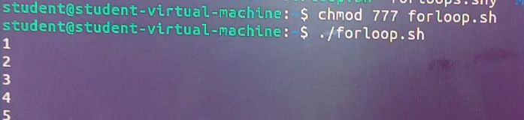

**Explaination:**

**for ((i=1; i<=5; i++)):** This initializes i to 1, sets the condition i<=5, and increments i by 1 after each iteration.

**echo " $i":** Prints the current value of i.

**done:** Ends the for loop.

**Q2. What is the syntax for a while loop that counts from 1 to 10 and prints each number?**

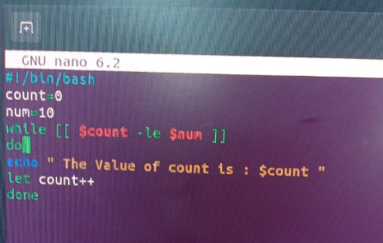

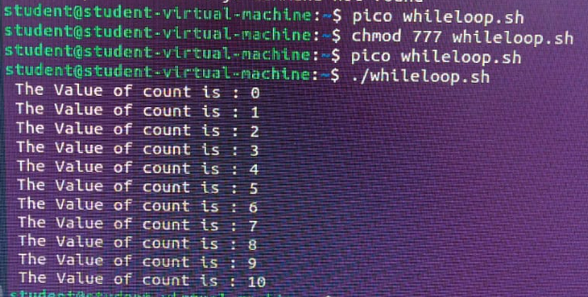

**Explaination:**

Initializes the variable count to 0. This variable will be used as a counter in the loop. Initializes the variable num to 10. This is limit for the counter. Starts a while loop that will continue as long as the condition [ $count -le $num ] is true. Here, -le means "less than or equal to," so the loop will run while count is less than or equal to 10. Increments the value of count by 1. The loop stops when count exceeds num (when count becomes 11)

**Q3. How would you write a nested loop in shell scripting to print a multiplication table from 1 to 3?**

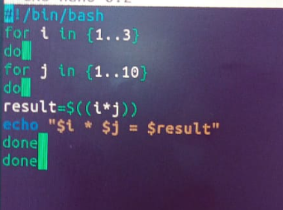

**Explaination:**

for i in {1..3}: This outer loop iterates over numbers from 1 to 3, representing the rows of the multiplication table. for j in {1..3}: This inner loop also iterates from 1 to 3, representing the columns. **result=$((i * j)):** Calculates the product of i and j.

**echo "$i * $j = $result":** Prints the multiplication result for each i and j.

**Q4: Write a for-in loop that iterates over the items in an array named fruits containing apple, banana, and cherry.**

**Explaination:**

This code contains an array named fruits of three items: "apple," "banana," and "cherry." It then uses a for-in loop to iterate over each element in the array, where the loop variable fruits takes on the value of each item in the array during each iteration. Inside the loop, it will prints the current fruit.

Q5: Write a while loop that reads user input until the user types "exit".

**Code:**

#!/bin/bash

while true

do

read -p "Enter num: " num

sleep 2s

done

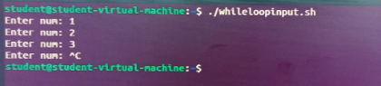

**Explaination:**

The user to enter a number with the message "Enter num :". The user input is then stored in the variable num.

This loop will keep taking Number from user until user exit from it.